Natural Gas Market Integration
A Key Factor for the Development of a Sustainable Energy System
Large natural gas projects often involve many countries and require appropriate investment and operational conditions. Solid public and private sector partnerships, guarantees and international contractual agreements are therefore of paramount importance to help solve major regional energy issues (from the 2006-2009 Triennial Work Programme)

Buenos Aires, October 8, 2009. On this day the theme of natural gas market integration was extensively covered. “Gas market integration was defined as one of the guidelines for the technical programme of this triennium” remarked Jorge Doumanian, Chair of the Task Force Gas Market Integration, IGU’s technical committee which dealt with this topic during the 2006-2009 triennium.
A morning session was conducted which introduced the Guiding Principles for Gas Market Integration, a model based on an extensive research and analysis of several gas market integration case studies around the world, with the objective of recognizing which are the key issues to be considered for a successful integration process.
The session was followed by a Strategic Panel in the afternoon, under the title “Finding the Links for Gas Market Integration”, with the participation of Alexander Medvedev of Gazprom, Gertjan Lankhorst of Gas Terra and Kazuo Kakehashi of Osaka Gas.
Being the cleanest and most efficient of the fossil fuels, natural gas displays a high potential to interact with renewable fuels, and is an ideal bridge to a sustainable energy system. However, the natural gas industry is facing two strong challenges: growth and globalisation.
These challenges will be hard to face if the right means are not established to enable regional – and eventually global markets through Liquid Natural Gas (LNG) - complement and develop.
There is – in general terms – a consensus about the advantages of natural gas market integration, in terms of both security of supply and demand.
Analysing the requirements that enable a process of increasing regional integration and balance, several factors must be take under consideration.
Besides geopolitics and cultural aspects, some of these determining factors that condition the integration possibilities include: type and structure of the markets and its relation with the energy policies, price formation, environmental legislation, infrastructure, and the amount of players involved. The following figure aims to illustrate the interaction of these factors in this complex system:
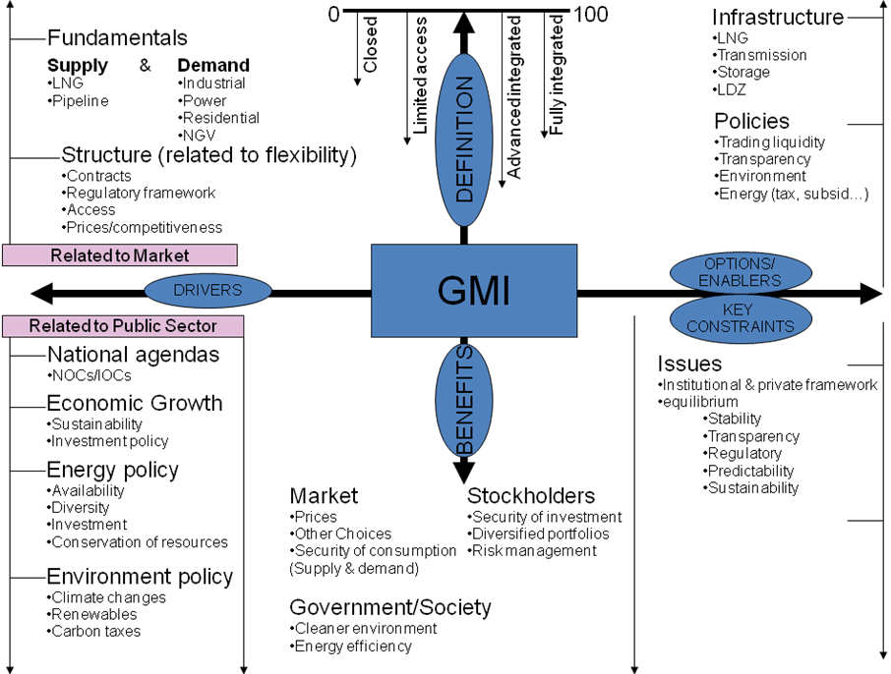

“The goal of the work conducted in the triennium and during the conference is to support the objective of the International Gas Union (IGU) to foster a healthy business climate within the gas industry and a spirit of constructive dialogue between the different players, both within the public and private sectors, so as to enable economic growth, social development and a sustainable energy system”, concluded Mr. Doumanian.

For more information contact:
IGU Secretariat
www.igu.org

