GUIDELINES FOR TECHNICAL PAPERS
‘CONEXPLO22’, MENDOZA, ARGENTINA

Marcos Cohen¹, Alejandra Castro²

¹ Pan American Energy SC. mcohen@pan-energy.com
² Instituto Argentino del Petróleo y el Gas. acastro@iapg.org.ar

Key words: Guidelines, Cited References, Figures

Abstract
This paper describes the editorial standards and general guidelines to write a technical paper for CONEXPLO22. The text formats to be used, the structure of the manuscript, and guidelines to present figures and mention the list of cited references are also included.
The Abstract should be written in Arial 10 (not bold or underlined). If the Paper is in Spanish, the Abstract should be written in English. If the Paper is in English, the Abstract should be written in Spanish. It should adjust to the Keywords.
The Abstract can contain a maximum of 400 words and should summarize the objectives, the methodologies used and the conclusions of the Paper. It should not contain images, figures, tables, or bibliographic citations. Likewise, it should not contain trade names of any kind. An Abstract is not the introduction or part of the introduction of the Paper.
To ensure that the correct text format is used, the Normal style should be defined as per the style gallery of this document.

GUIDELINES

This section describes the Guidelines to prepare a Technical Paper for CONEXPLO22.
Authors should consider every text configuration and format described in this document since they are predefined in the file.
The paper should be structured in such a way that a reader can easily find the information from the Introduction, Methodologies and Results to the Conclusions. At the end of the Paper, the Cited References should be included.
Every author should follow the editorial guidelines. The non-compliance of these guidelines should result in a rejection of the Paper.
To make the Technical paper writing easier, this Word document has four predefined text styles that can be accessed through the Style Gallery (Fig. 1).

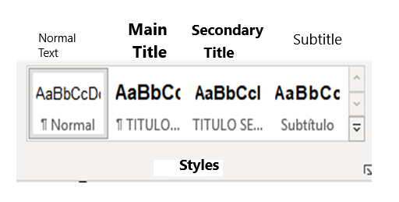

Figure 1. Predefined text styles.

  - Page size and margins
Technical Papers should be written in Microsoft Word. Page size should be A4 (21,0 cm x 29,7 cm) with a Dialog Box of 17,0 cm x 25,5 cm.
To this purpose, margins should be set as follows (Fig. 2): Top: 3 cm; Bottom: 2,2 cm; Left: 2,0 cm; Right: 2,0 cm.

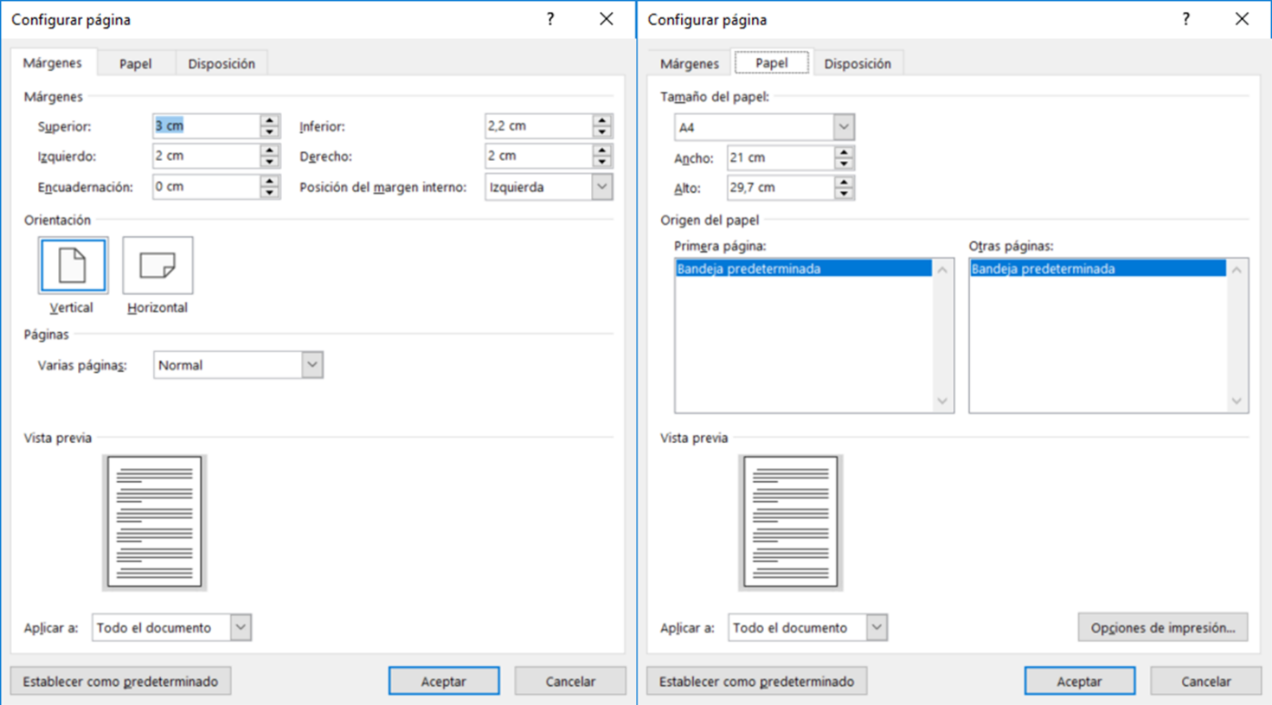
Figure 2: page and margin settings.

  - Spacing and alignment
Single spacing should be used, with spacing before and after 0 pt. Alignment should be justified and no indentation used. Figure 3 shows the settings for these two options.

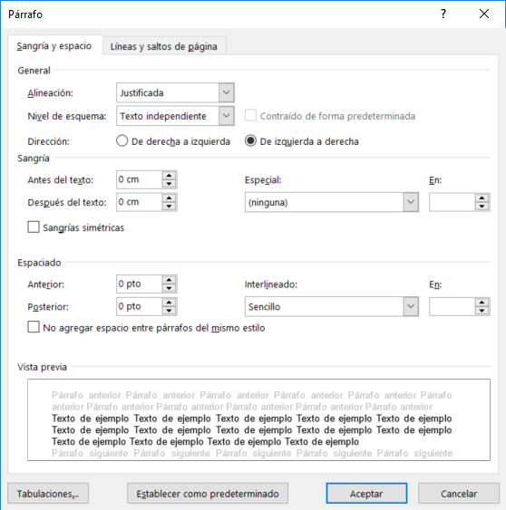
Figure 3: spacing and alignment settings.

  - Language

The Papers should be written in Spanish or in English. The Papers written in English should be included in the ‘Resumen’ (i.e., Abstract) in Spanish and the Papers written in English should include an Abstract in Spanish.
The words in other languages, different from that of the Paper, should appear in italics. For example, the words Keywords, Permian Basin or et. al that are included as citations.

  - Paper length

The Papers should have a minimum length of 6 pages and a maximum length of 20 pages, and in both cases include the Abstract, the figures, and CITED REFERENCES.

  - File size

According to SISCON limitations, the maximum size of the final paper is 100 MB. If the file size exceeds the specified, please contact acastro@iapg.org.ar.

TeCHNICAL paper LAYOUT

This section describes how to organize the Paper. Please consider that Papers have no Index.

  - Main Title

The Paper starts with a Main Title. This title should have no abbreviations, and should be concise, informative, and representative of the contents.
Text should be in Arial 12, uppercase, bold font and centered. The predefined style MAIN TITLE should be used.

  - Author’s Name and Institutional Affiliation

Every Author should appear with his / her Name and Surname (double spacing) under the main title. At the end of each surname, the number indicating the Author’s affiliation should be added as superscript.

The affiliation and e-mail of the author should be stated under his / her name and surname (double spacing) and follow the exact order of appearance.

  - Keywords

After the Author’s e-mail address, separated by double spacing, keywords should appear in a maximum of five letters.
Text should be Arial 10, bold, in Spanish or English according to the language of the Paper.

  - Abstract or Resumen

Following the Keywords, separated by double spacing, a text in English should be included for the papers in Spanish and vice versa, with the title ABSTRACT or ‘RESUMEN’, (without colon).
The text should be separated from the title by single spacing and written in English for Papers in Spanish and vice versa and should have a maximum of 250 words.
A good Abstract should include information about objectives, available data and describe the methodology employed, followed by the analysis and interpretation of the information, results, and the most relevant observations, including the quantitative information (if any), and should end with the main conclusions and implications of the study and include quantitative information if available and should end with the main conclusions and implications of the study.
.
Normal style should be used (Arial 10, justified).

  - Main text

Separated by double spacing from the Abstract or ‘Resumen’, the text should be organized in a logical order: Introduction, Methodology, Results, Conclusions, Acknowledgements and Cited references.
The text can be subdivided into Secondary Titles and Subtitles.

Secondary Titles:
Used to arrange the Paper. They are mandatory.
Arial 11, uppercase, bold, justified. Style: SECONDARY TITLE in the document.

Subtitles:
Used as an option to give more details about the internal layout of the Paper.
Arial 11 uppercase and lowercase, bold, justified. Style: SUBTITLE in the document.

The text is separated by a single spacing in the secondary titles and in the subtitles.

  - References

The citations of any work mentioned in the text should be included at the end of the Paper under the Secondary Title ‘CITED REFERENCES’.
Citations in the text should follow these guidelines:
  - For one author of the text his/her Surname and Year of publication should be included between brackets. Example: Caminos (1975).
  - In the case of Two Authors, both Surnames and the Year of publication should be included between brackets: Example: Legarreta and Uliana (1999)
  - In the case of Three or more Authors the Surname of the first Author should be included followed by et al. (in italics). Example: López et al. (1990).
  - When more than one Paper by the same Author is cited, they should be separated by a comma. For Example: Caminos (1956, 1978).
  - The citations included between brackets should not use a comma to separate the Author from the Year. For example: (Caminos 1956)
  - If several Authors are included between brackets, they should be separated by a semicolon. For example: (Caminos 1975; González Díaz 1986, 1994).
  - If several Papers by the same Author and from the same Year are cited, the Year should be followed by letters: a, b, c, in accordance with the order of publication (Mainardi 1994a).

- In the section CITED REFERENCES the citations should conform to the following guidelines:

  - Name of Authors:
    - One author: Surname, Name, year.
    - Two authors: Surname, Name and Surname, Name, year.
    - Three or more authors: Surname, Name, Surname, Name and Surname, Name, year.
  - Name of publication and source.
    - Magazines:
  - Indicate the complete name of the Magazine, volume and first and last page and place of publication.
  - E.g.: Aramayo Flores, R.F., 1989, El cinturón plegado y sobrecorrido del norte argentino, Boletín de Informaciones Petroleras, Tercera Época, Año VI, N° 17, p. 2-16, Buenos Aires.
    - Books:
  - Specify the Book name, the publisher and number of pages.
  - E.g.: Nelson, R., 2001. Geologic Analysis of Naturally Fractured Reservoirs, 2nd edition. Gulf Professional Publishing, 332pp.
    - Book chapters or special publications:
  - Indicate the title of the Chapter, the publisher, title of the Book and number of pages per chapter.
  - E.g.: Belotti, H.J., Sacavino, L.L. and Schachner G.A.,1995. Structural styles and petroleum occurrence in the Sub-Andean fold and thrust belt of northern Argentina. En Tankard, A., Suarez, S. y Welsink, H. (eds.), Petroleum Basins of South America. American Association of Petroleum Geologists Memoir 62, pp. 545-555.
    - Congress Minutes:
  - Indicate the name of Paper, Congress or Event and venue.
  - E.g.: Disalvo, A. y Villar, H.J., 1999. Los Sistemas Petrolíferos del Area Oriental de la Cuenca Paleozoica Noroeste, Argentina, IV Hydrocarbon Exploration and Development Congress, IAPG, Minutes I, p.83-100, Mar del Plata, Argentina.
    - Unpublished papers (Thesis, Technical reports, etc.):
  - Indicate the paper name, Congress or event and venue.
  - E.g.: Limeres, M., 1992. Paleotectónica y Sedimentación del Grupo Cuyo en el Oeste de la Dorsal Neuquina. YPF. Unpublished report.
    - Websites
  - Indicate the website and login dates.
  - E.g.: CBHE, 2008 for the Website of The Bolivian Chamber of Hydrocarbons & Energy, http://www.cbh.org.bo, Statistics – Reserves – Production. Login date: March 10th, 2008.

FigurEs

The term figures refers to images or illustrations included in the Paper: tables, maps, cut-outs, graphs or cross-plots, strategic columns, photos, satellite images, etc.
Images should be included in the text according to the Author’s criteria and be TIFF file format, CMYK (color model) and 300 dpi.
The suggested sizes are images of total page width (245 mm) or half page width (122,5 mm).
Some guidelines to have in mind:
• Maps should mention the Scale, Coordinates, North arrow, and References. The Coordinate System used should be also indicated. (Fig. 4).
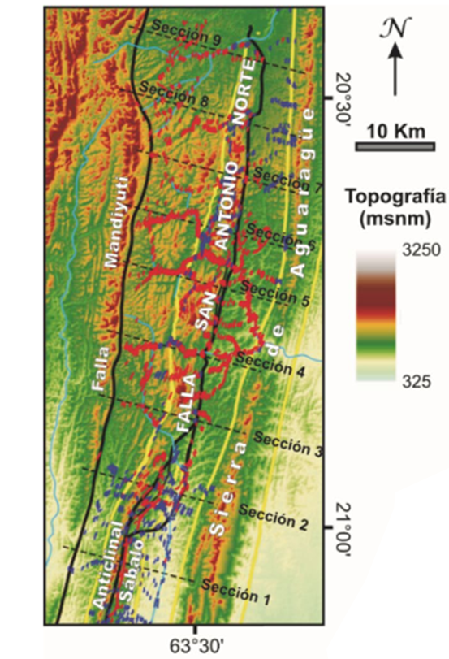
Figure 4. Example map including Scale, North arrow, Coordinates and References. Source: Giampaoli and Vera (2018).

• The cut-outs and/or seismic sections should include the horizontal scale, vertical scale and traces should be indicated in a location map. This map could be part of the figure or refer to another picture or graph in the Technical Paper (Fig. 5). The cut-out orientation should be clearly indicated.
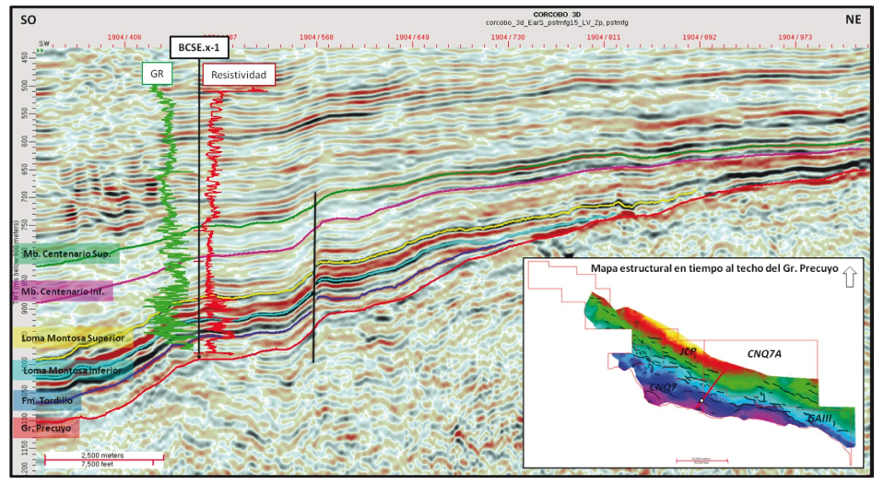
Figure 5. Example of cut-out or section including horizontal scale, vertical scale, cut-out trace and cut-out orientation. Source: Iñigo et al. (2018)

• Every Cartesian graph or cross-plot between 2 or more variables, should include the title and axis scale (Fig. 6).
• The photos should have an explicit or qualitative reference scale.
• Figures should use consecutive Arabic numerals as they appear in the technical paper.
• The text should refer to figures as Fig. or Figs., in both cases this should appear between brackets. If a figure is mentioned within the text, it shouldn’t be between brackets or as an abbreviation.

Every figure should have an epigraph describing its content. If the picture contains two or more graphics, these should be referred as a), b), c), etc. and the epigraph should mention each of them. The text of epigraphs should be Arial 10, justified and Normal style.

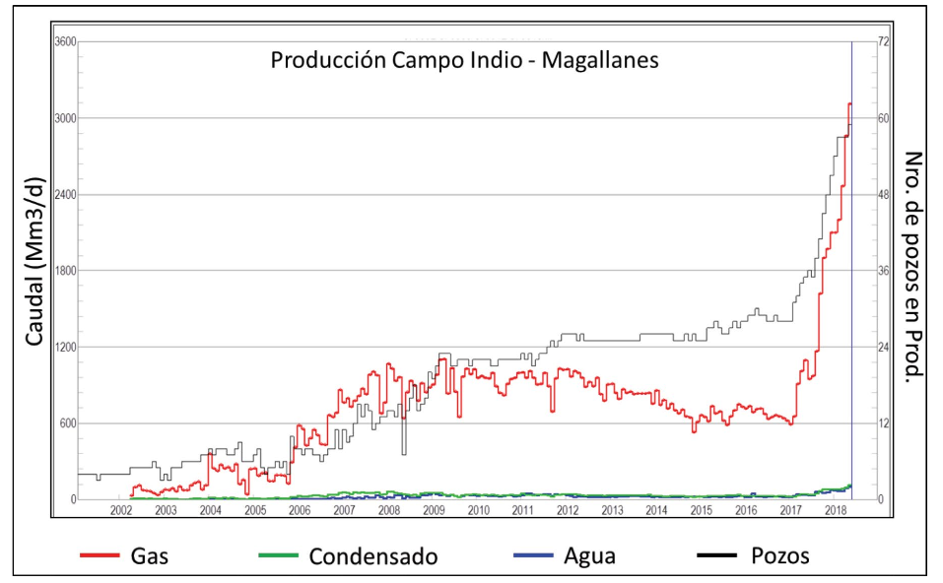
Figure 6. Example of graph or cross-plot, clearly indicating titles and axis scales and the references of graph variables. Source: Aimar et al. (2018).

ACKNOWLEDGEMENTS
The authors wish to thank Claudia Borbolla, Marcelo Santiago, Marco Gardini and Pablo Giampaoli for their suggestions and contributions.

REFERENCE LIST
Aimar, E., Cevallos, M., Cangini, A., Mas Cattapan, F. y Vega, V., 2018. X Congreso de Exploración y Desarrollo de Hidrocarburos, IAPG. Actas Simposio de Desarrollo, pp. 203-220.

Aramayo Flores, R.F., 1989, El cinturón plegado y sobrecorrido del norte argentino, Boletín de Informaciones Petroleras, Tercera Época, Año VI, N° 17, p. 2-16, Buenos Aires.

Belotti, H.J., Sacavino, L.L. y Schachner G.A.,1995. Structural styles and petroleum occurrence in the Sub-Andean fold and thrust belt of northern Argentina. En Tankard, A., Suarez, S. y Welsink, H. (eds.), Petroleum Basins of South America. American Association of Petroleum Geologists Memoir 62, pp. 545-555.

C.B.H., 2008, Sitio Web de la Cámara Boliviana de Hidrocarburos, http://www.cbh.org.bo, Estadísticas – Reservas – Producción. Acceso 10 de marzo de 2008.

Disalvo, A. y Villar, H.J., 1999. Los Sistemas Petrolíferos del Area Oriental de la Cuenca Paleozoica Noroeste, Argentina, IV Congreso Exploración y Desarrollo Hidrocarburos, IAPG, Actas I, p.83-100, Mar del Plata, Argentina.

Giampaoli, P. y Rojas Vera, E., 2018. Crecimiento y conexión lateral de pliegues en la Faja Plegada y Corrida del Subandino Sur de Argentina y Bolivia. X Congreso de Exploración y Desarrollo de Hidrocarburos, IAPG. Actas Sesiones Generales, pp. 553-556.

Iñigo, J., Vargas, R., Novara, E., Pereira, D. y Schwarz, E., 2018. La Formación Loma Montosa en el borde nororiental de la Cuenca Neuquina: Análisis secuencial, caracterización paleoambiental y prospectividad remanente. X Congreso de Exploración y Desarrollo de Hidrocarburos, IAPG. Actas Sesiones Generales, pp. 623-646.

Limeres, M., 1992. Paleotectónica y Sedimentación del Grupo Cuyo en el Oeste de la Dorsal Neuquina. YPF. Informe inédito.

Nelson, R., 2001. Geologic Analysis of Naturally Fractured Reservoirs, 2nd edition. Gulf Professional Publishing, 332pp

